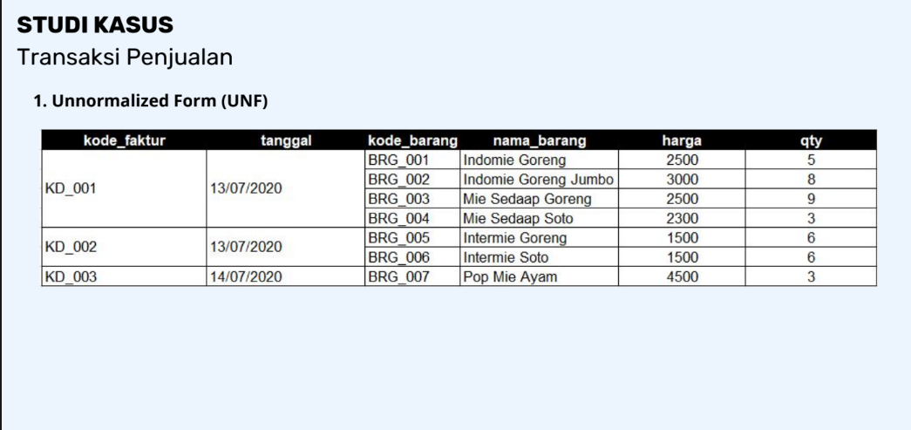
- First Normal Form (1NF)
Kode_Faktur | Tanggal | Kode_Barang | Nama_Barang | Harga | Qty
KD_001 | 13/07/2020 | BRG_001 | Indomie Goreng | 2500 | 5
KD_001 | 13/07/2020 | BRG_002 | Indomie Goreng Jumbo | 3000 | 8
KD_001 | 13/07/2020 | BRG_003 | Mie Sedaap Goreng | 2500 | 9
KD_001 | 13/07/2020 | BRG_004 | Mie Sedap Soto | 2300 | 3
KD_002 | 13/07/2020 | BRG_005 | Intermie Goreng | 1500 | 6
KD_002 | 13/07/2020 | BRG_006 | Intermie Soto | 1500 | 6
KD_003 | 14/07/2020 | BRG_007 | Pop Mie Ayam | 4500 | 3

- Second Normal Form (2NF)
Tabel Faktur
Kode_Faktur | Tanggal | Kode_Barang | Qty
KD_001 | 13/07/2020 | BRG_001 | 5
KD_001 | 13/07/2020 | BRG_002 | 8
KD_001 | 13/07/2020 | BRG_003 | 9
KD_001 | 13/07/2020 | BRG_004 | 3
KD_002 | 13/07/2020 | BRG_005 | 6
KD_002 | 13/07/2020 | BRG_006 | 6
KD_003 | 14/07/2020 | BRG_007 | 3

Tabel Barang
Kode_Barang | Nama_Barang | Harga
BRG_001 | Indomie Goreng | 2500
BRG_002 | Indomie Goreng Jumbo | 3000
BRG_003 | Mie Sedaap Goreng | 2500
BRG_004 | Mie Sedap Soto | 2300
BRG_005 | Intermie Goreng | 1500
BRG_006 | Intermie Soto | 1500
BRG_007 | Pop Mie Ayam | 4500

- Third Normal Form (3NF)
Tabel Faktur
Kode_Faktur | Tanggal
KD_001 | 13/07/2020
KD_002 | 13/07/2020
KD_003 | 14/07/2020

Tabel Barang
Kode_Barang | Nama_Barang | Harga
BRG_001 | Indomie Goreng | 2500
BRG_002 | Indomie Goreng Jumbo | 3000
BRG_003 | Mie Sedaap Goreng | 2500
BRG_004 | Mie Sedap Soto | 2300
BRG_005 | Intermie Goreng | 1500
BRG_006 | Intermie Soto | 1500
BRG_007 | Pop Mie Ayam | 4500

Tabel Detail Faktur Transaksi
Kode_Faktur | Kode_Barang | Nama_Barang | Harga | Qty
KD_001 | BRG_001 | Indomie Goreng | 2500 | 5
KD_001 | BRG_002 | Indomie Goreng Jumbo | 3000 | 8
KD_001 | BRG_003 | Mie Sedaap Goreng | 2500 | 9
KD_001 | BRG_004 | Mie Sedap Soto | 2300 | 3
KD_002 | BRG_005 | Intermie Goreng | 1500 | 6
KD_002 | BRG_006 | Intermie Soto | 1500 | 6
KD_003 | BRG_007 | Pop Mie Ayam | 4500 | 3

DESIGN DATABASE
*
1
1
*
Tbl_barang
Kode_barang Varchar(20)Primary Key;
Nama_barang Varchar(50);
Harga int;
Tbl_faktur
Kode_faktur Varchar(20)PrimaryKey;
Tanggal Date;
Tbl_DetailTransaksi
Kode_faktur Varchar(20)Foreign Key;
Kode_barang Varchar(20) Foreign Key;
Qty int;

